**IFT 466 Advanced Computer Networks**

**Lab 6  
EIGRP – Load & Reliability (Metrics)**

After you complete each step, put a ‘√’ or ‘x’ in the completed box

**Objective**Gain an understanding in how changing the load and reliability metrics effect how routers setup with the EIRGP protocol operate.

1. Setup up the following topology on Packet Tracer

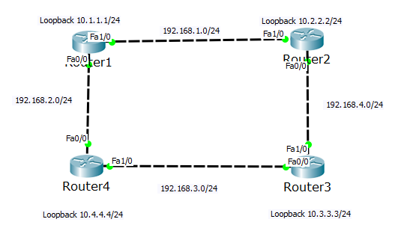



✓

1. Configure the routers with the loopback addresses as outlined on the topology.  
     
   Disable auto-summarization via the no auto-summary command



✓

1. Enable the EIGRP routing process on each router using AS number 100

Advertise directly connected networks via the network command



✓

1. Now you should be able to ping any routers loopback from any other router and this steps 1 to 3 completed.

  
 ✓

1. As you know from the presentations, EIGRP use 5 metrics for path calculations.  
     
   Run the show ip protocols command on R1 and we can see the 5 metrics (bandwidth, load, delay, reliability and MTU).

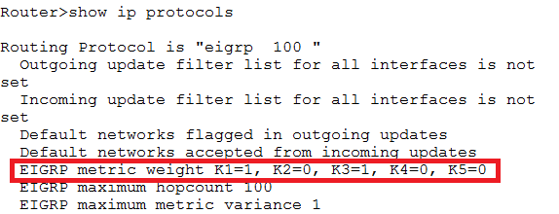



✓

1. We will change the load (K2 from 0 → 2) and reliability (K4 from 0 → 2)

In R1, type the following commands

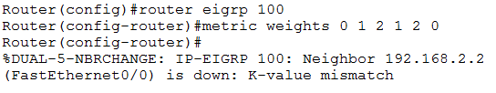

Metric weights, we will configure 0 first, this is the TOS (Type of service) so we do not need it.

We will leave K1 (bandwidth) default value of 1

We will change K2 (load) to 2

We will leave K3 (delay) to default value of 1

We will change K4 (reliability) to 2

We will leave K5 (MTU) is default value of 1

 ✓

1. As you see, we lose the neighbor adjacencies due to the mismatch.

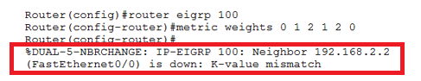

We need to match the K values on each router otherwise router cannot communicate with other routers.

 ✓

1. Run the show ip route and you will see we lost all routes from the table

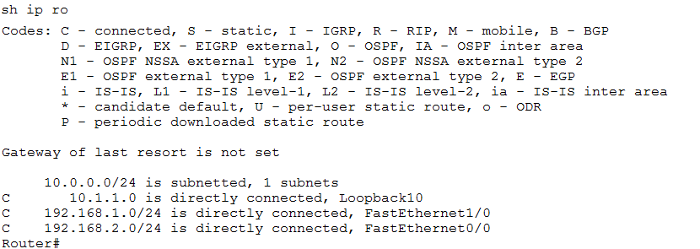

 ✓

1. ****Now go to R2 and you will see the same mismatch errors.  
     
    ✓
2. To fix this, we need go to R2 and the other routers and change their metric values to match that of R1  
     
   Once you change the metrics on these other routers, then the adjacencies will come back up.



✓

1. Now that you have updated the 3 routers with the new metrics, go back to R1 and run the show ip route and the routes should now be back in the route table.



✓

1. ****You now be able to ping the loopback addresses as before.

✓

